MEDICAL INVENTORY MANAGEMENT

## College Name: KPR COLLEGE OF ARTS SCIENCE AND RESEARCH

TEAM ID:EDB3A51D595E2BDAF964E1EEA380889B

TEAM MEMBERS:4

Team Leader Name: AVINASH V S

Email: 23bcs010@kprcas.ac.in

Team Member1: PRASANTH K K

Email: 23bcs045@kprcas.ac.in

Team Member2: NAVYA M V

Email: 23bcs039@kprcas.ac.in

Team Member3: RAJA AKSHAYA V

Email: 23bcs049@kprcas.ac.in

# INTRODUCTION

Project Overview

This project is a comprehensive Salesforce application to streamline and manage various operational aspects of medical inventory. The system aims to efficiently maintain supplier details, manage purchase orders, track product details and transactions, and monitor the expiry dates of products. Maintain detailed records of suppliers, including contact information. Catalog product information, including descriptions, stock levels. Monitor and track product expiry dates to avoid using expired items. Comprehensive reports to track supplier performance, and purchase orders.

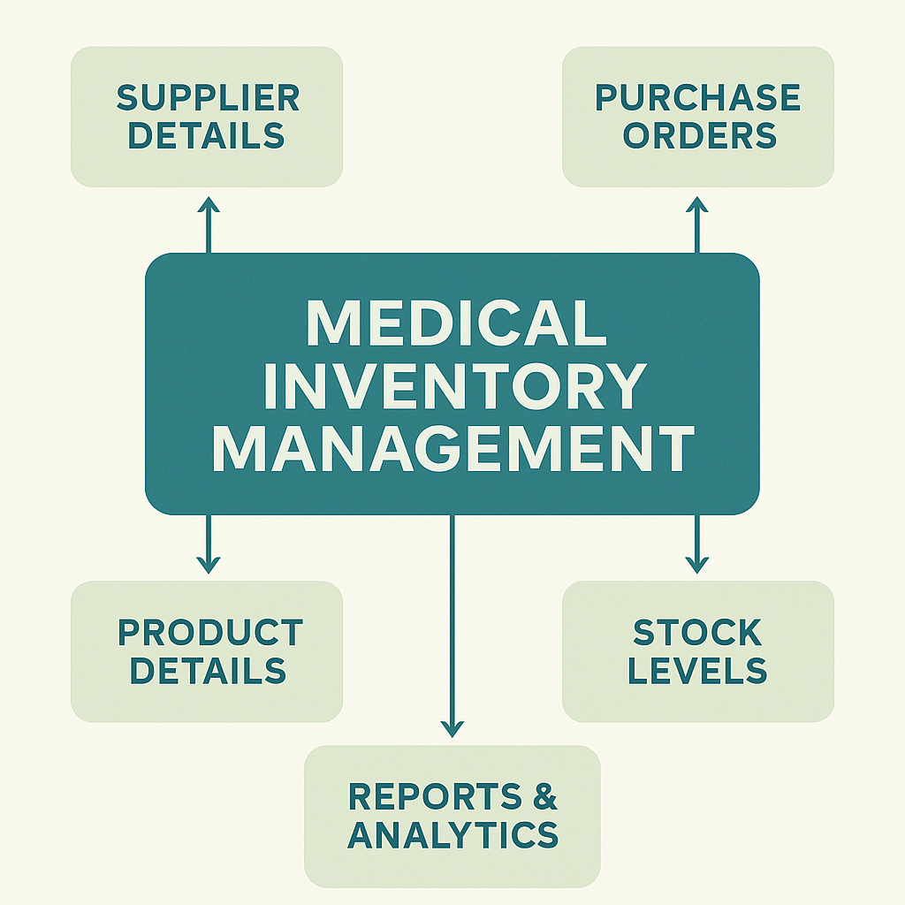

Purpose  
The purpose of this project is to develop a Salesforce-based medical inventory management system that ensures efficient tracking of suppliers, purchase orders, product details, and expiry dates. It aims to streamline operations, reduce errors, prevent the usage of expired items, and provide comprehensive reports for better decision-making and supplier performance evaluation.

Student Outcome:

* Students gained practical knowledge in developing and customizing Salesforce applications by creating objects, fields, and layouts tailored for medical inventory management.
* They learned to design and manage database structures, establish relationships between objects, and implement validation rules to ensure data accuracy and reliability.
* They acquired hands-on experience in automation by working with flows, triggers, and formula fields to streamline processes like purchase order calculations and inventory tracking.
* Students developed analytical and reporting skills by creating detailed reports and dashboards, enabling them to visualize data and support real-time decision-making in business environments.

**Objectives:**

* To design and implement a Salesforce-based system for efficient medical inventory management.
* To maintain accurate records of suppliers, products, purchase orders, and transactions.
* To track stock availability and monitor expiry dates to prevent the use of expired items.
* To automate processes such as order calculations, validations, and updates using flows and triggers.
* To generate comprehensive reports and dashboards for analyzing supplier performance and purchase details.
* To enhance decision-making through real-time insights and data visualization.

DEVELOPMENT PHASE

Creating Developer Account:

By using this URL - <https://developer.salesforce.com/signup>.

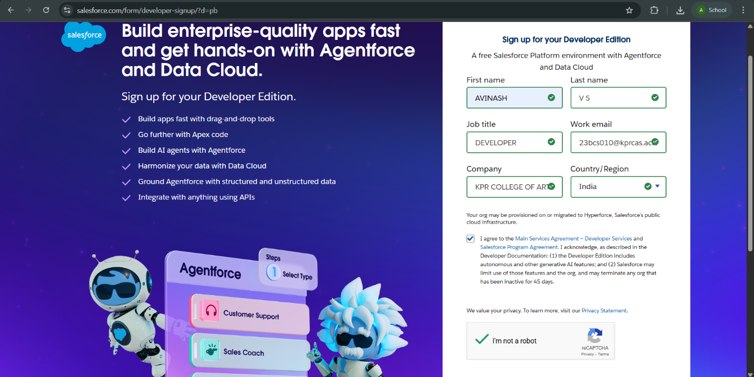

* After creating developer account,Go to setup page and create the object.

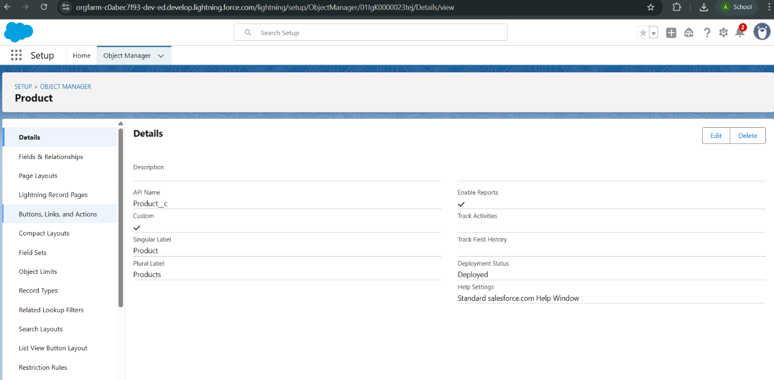

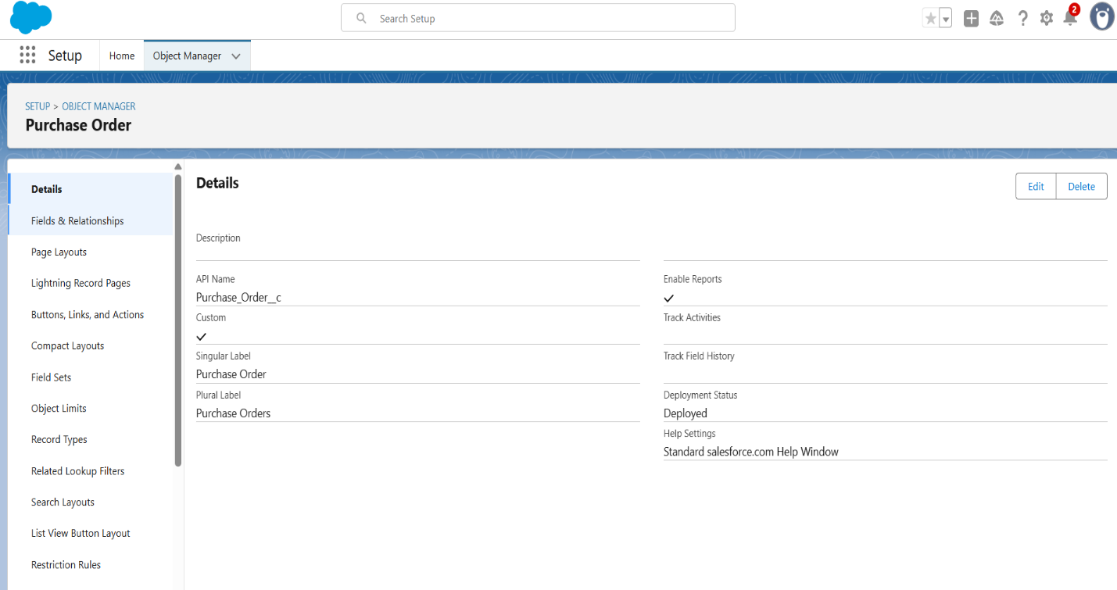

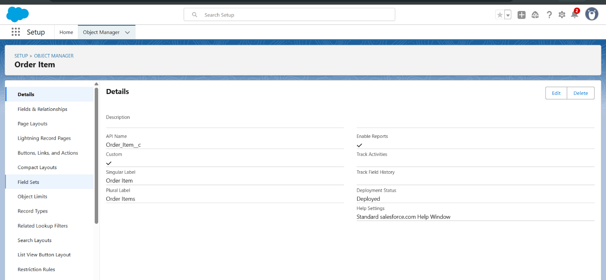

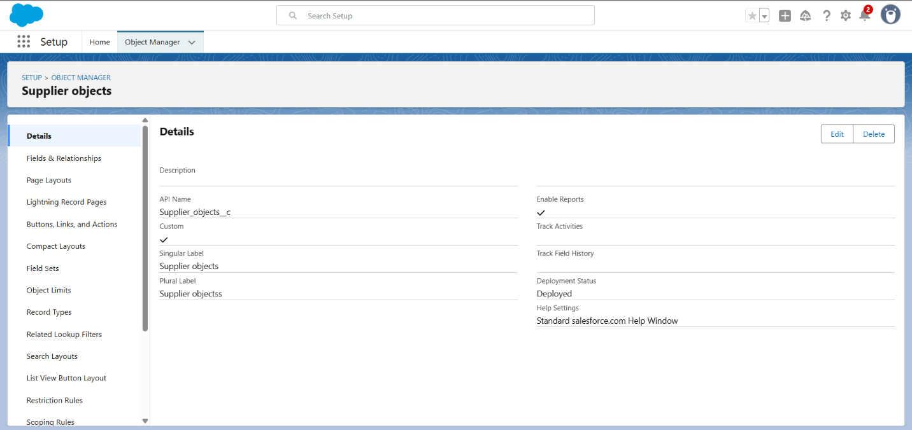

* All the given objects has been created.
* Created the five tabs inventory transaction,order item,product,purchase order,supplier objects.

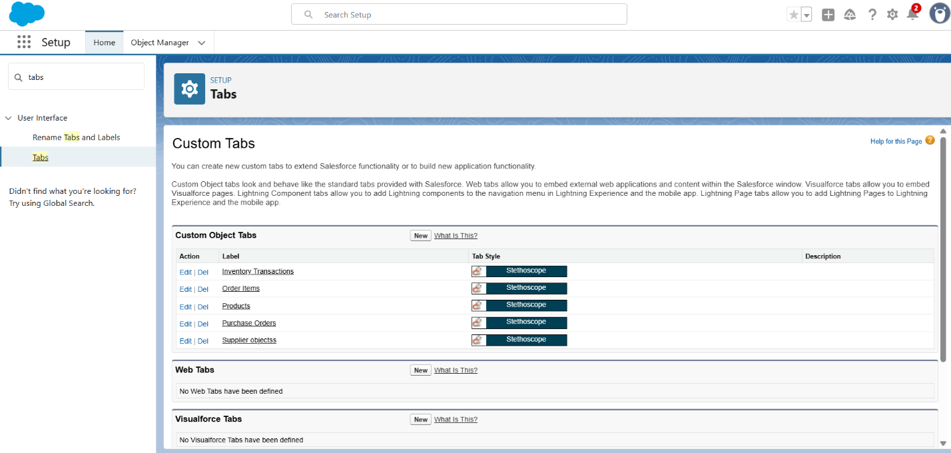

* Created a lightning app for Medical Inventory Management.

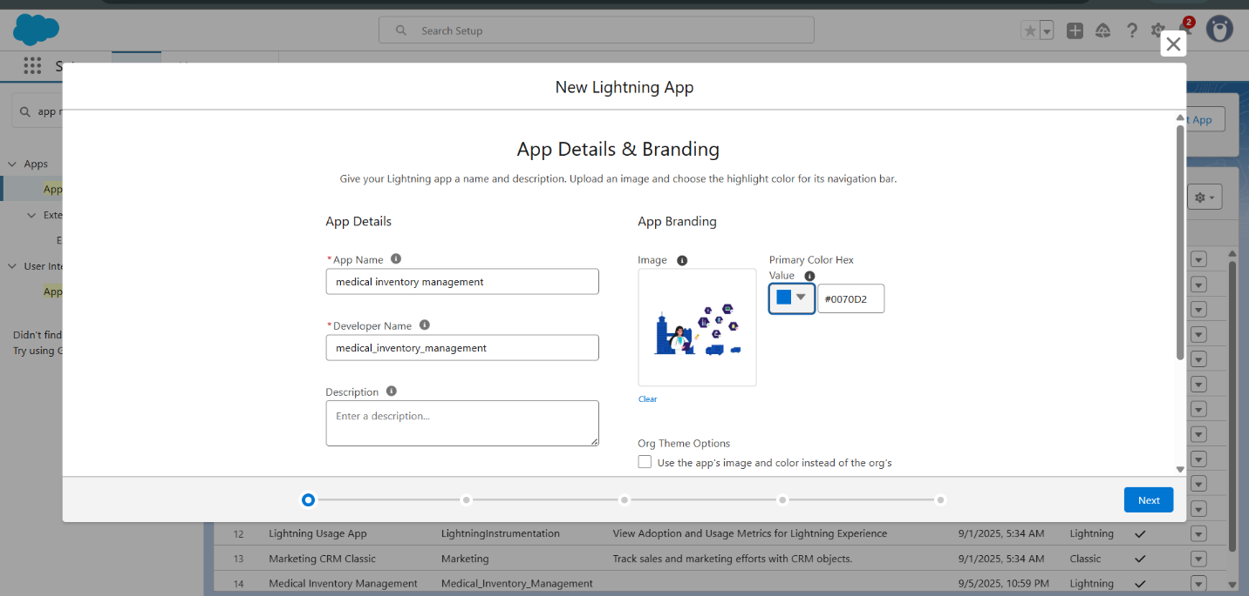

* Created a text field in product object.

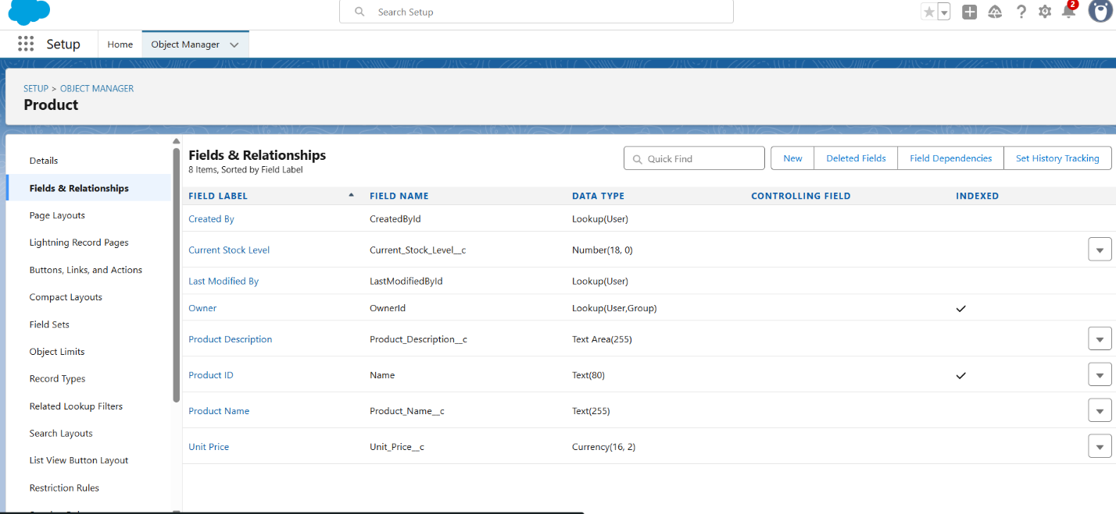

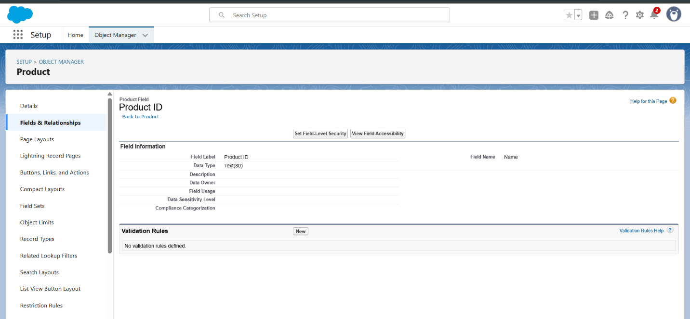

* Created a textArea in product object.

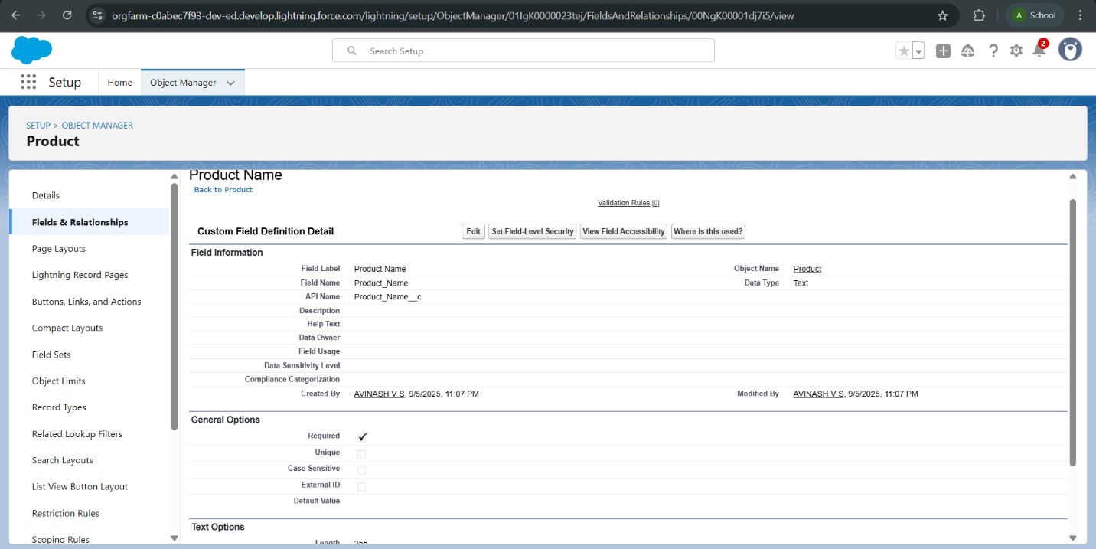

* Created a number field in product object.

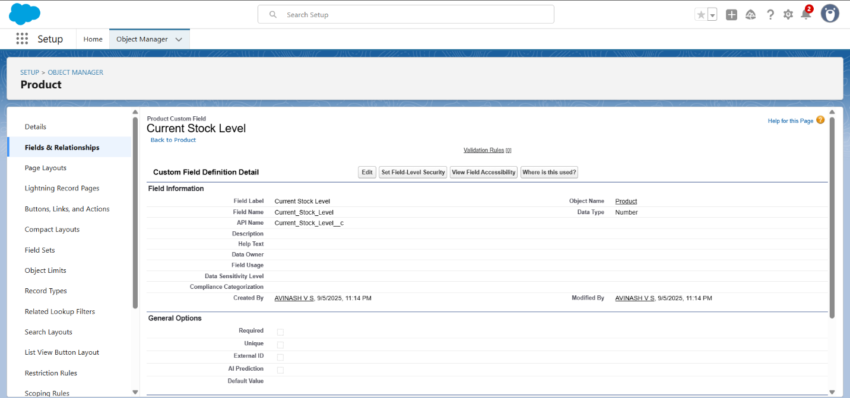

* Created a currency field in product object.

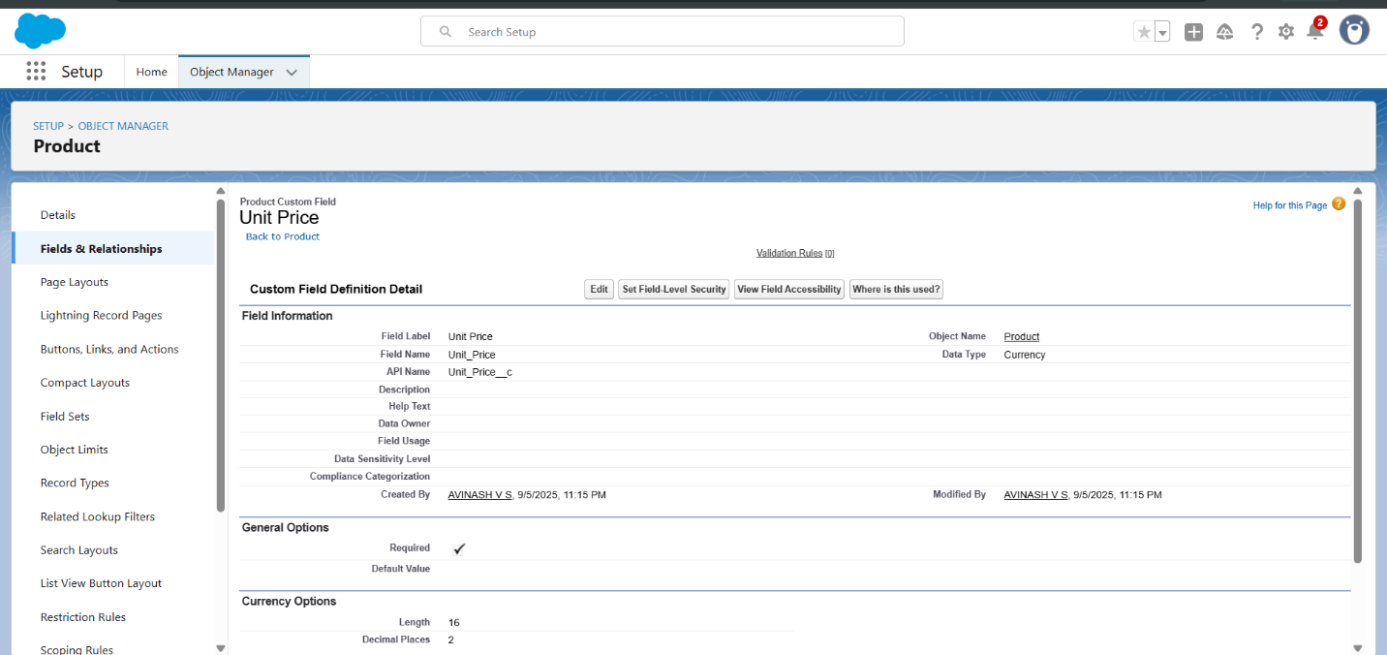

* Created a lookup relationship,date field,roll up summary in purchase order.

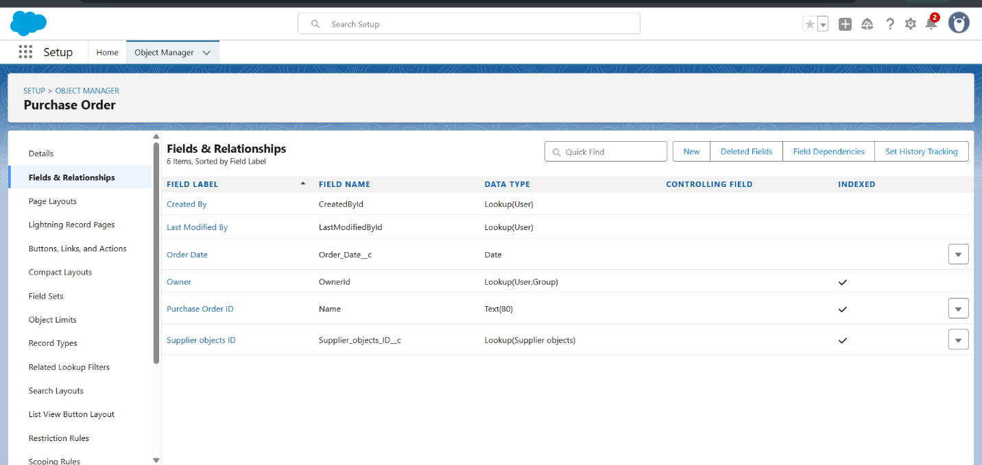

* Created a unit price formula, amount formula field in order item.

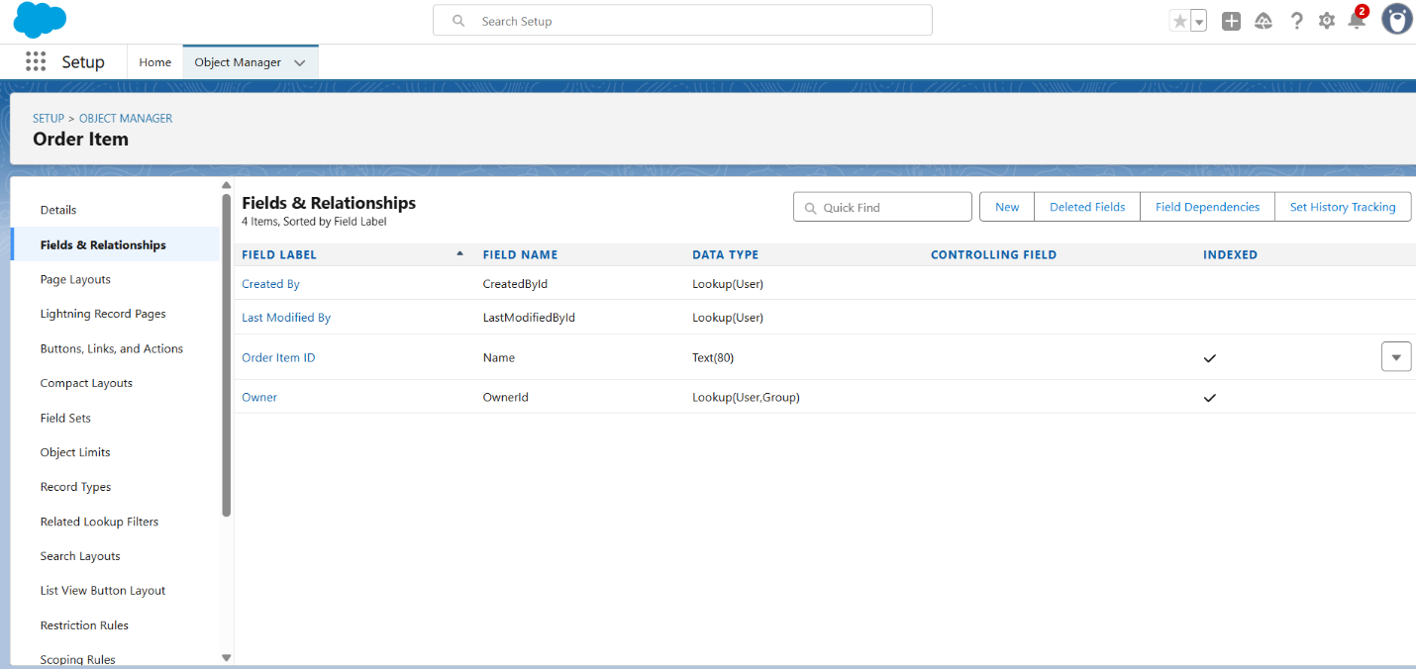

* Created a picklist, total order cost field in inventory transaction .

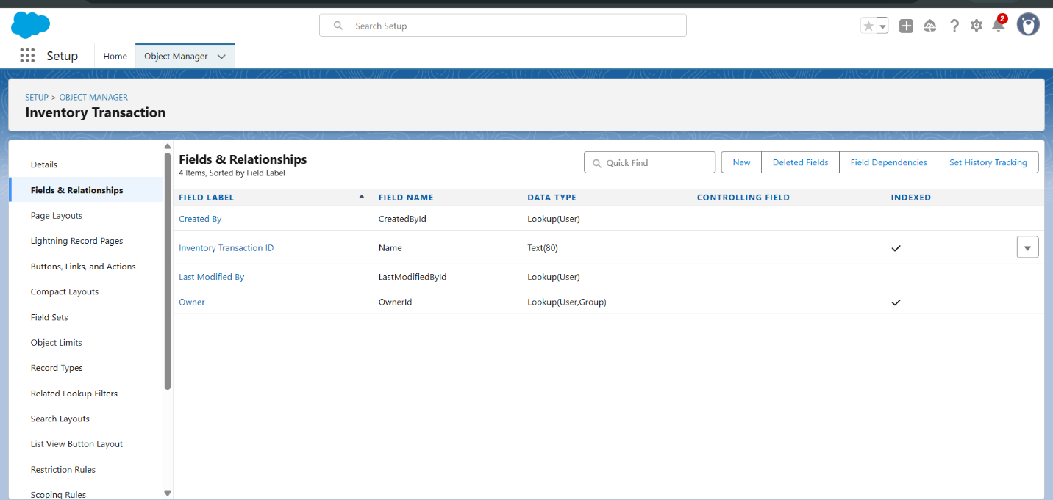

* Created a phone,email field in supplier object .

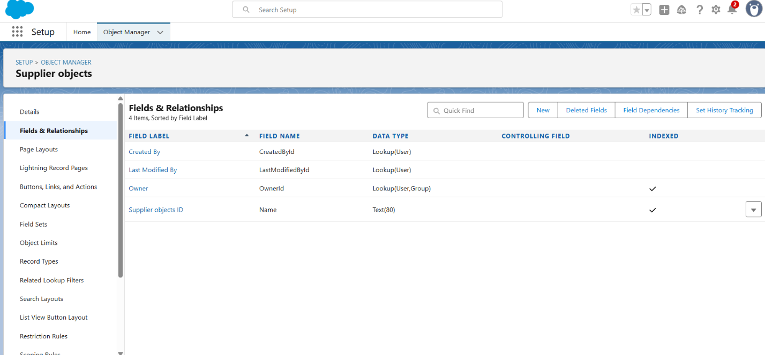

* Edit page layouts in product,purchase order,order item,supplier object,inventory transaction.

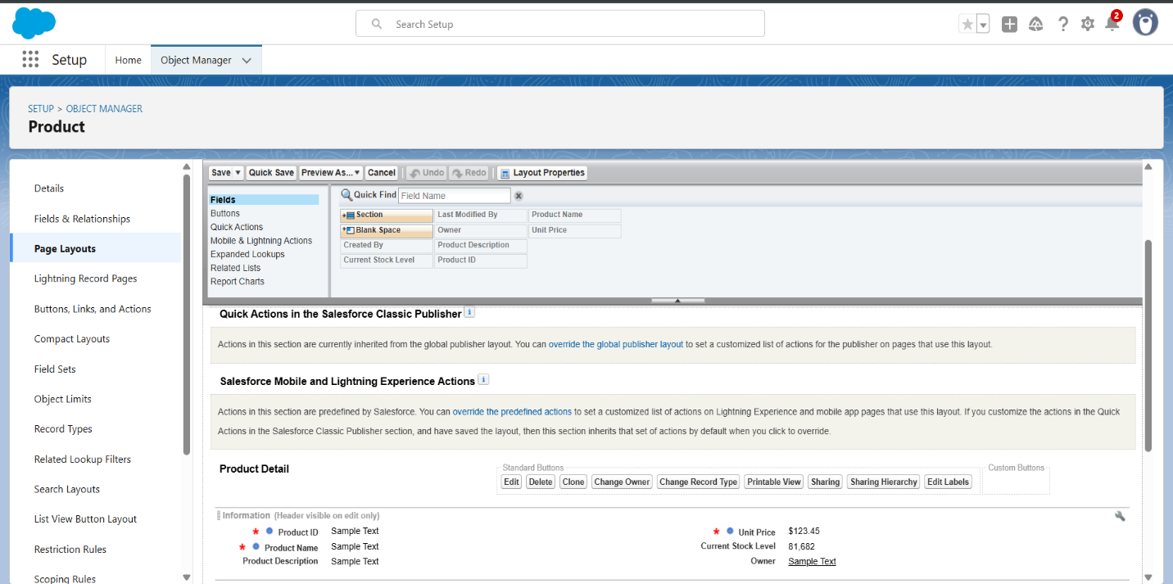

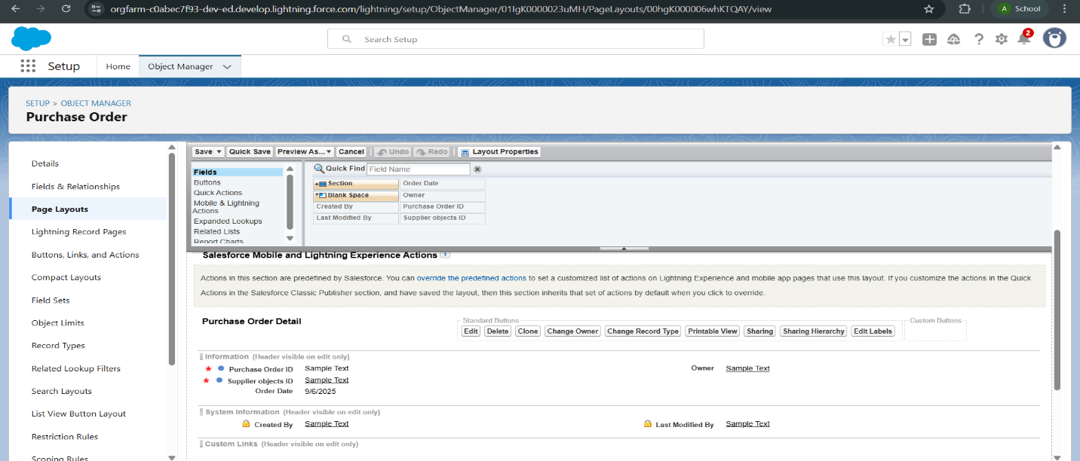

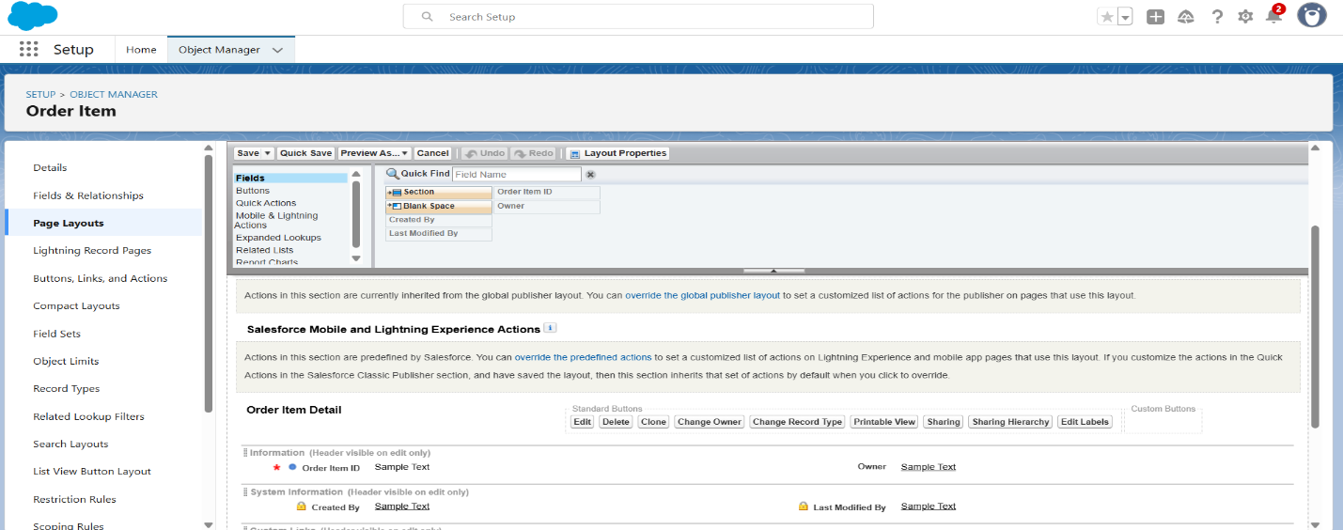

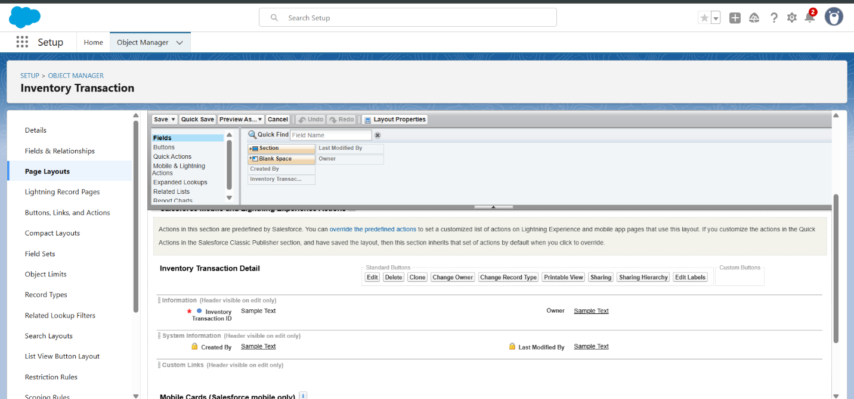

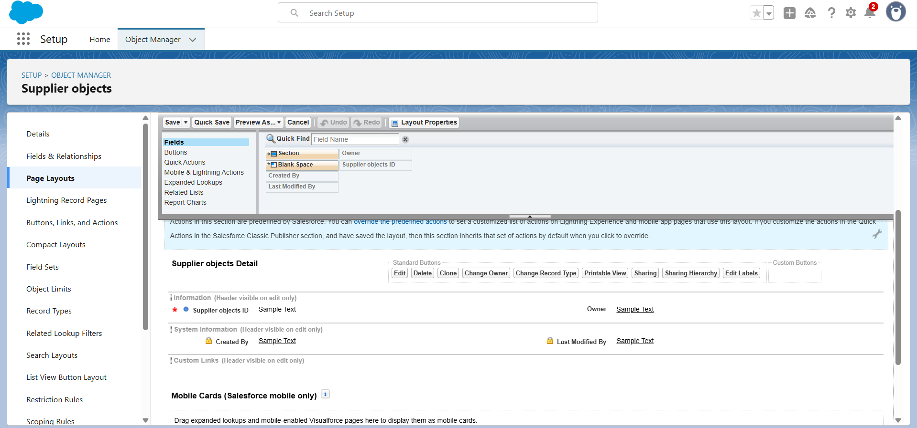

Compact layout

* Created compact layout for product.

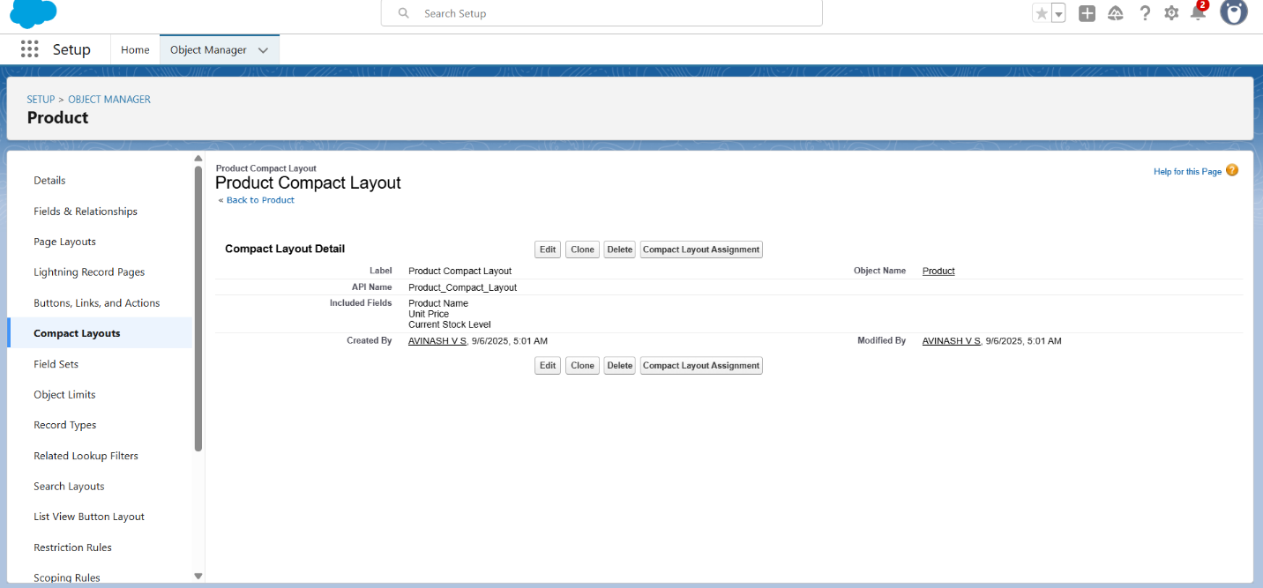

* Created compact layout for purchase object.

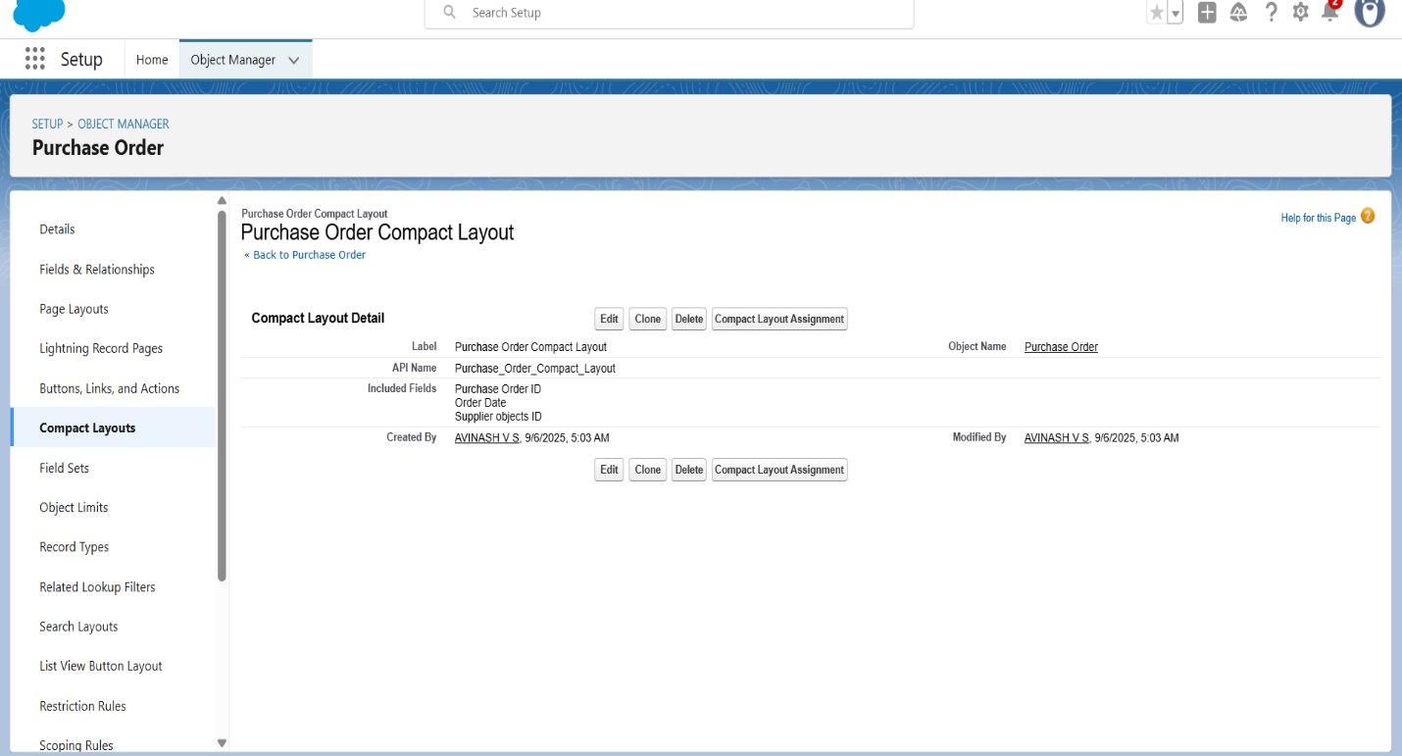

Validation rules

* create an Expected Delivery Date Validation rule to a Employee Object.

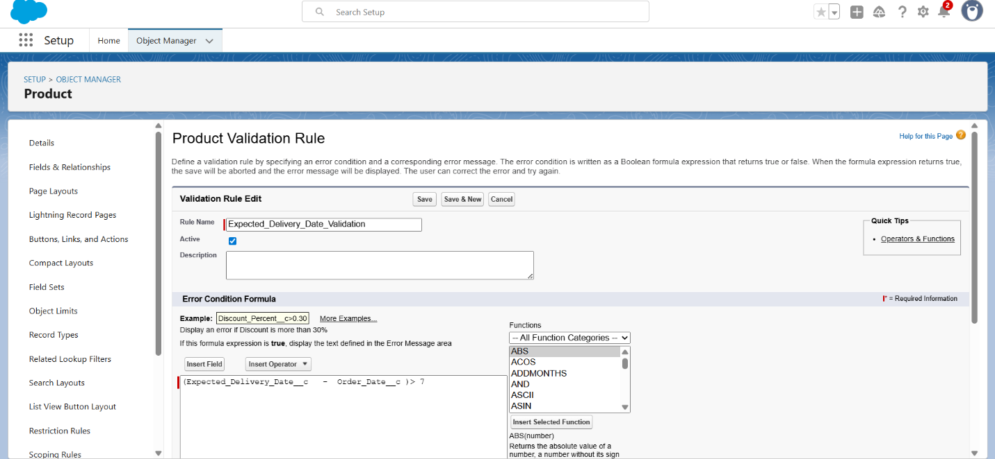

Profile

* created an inventory and purchase manager profle.

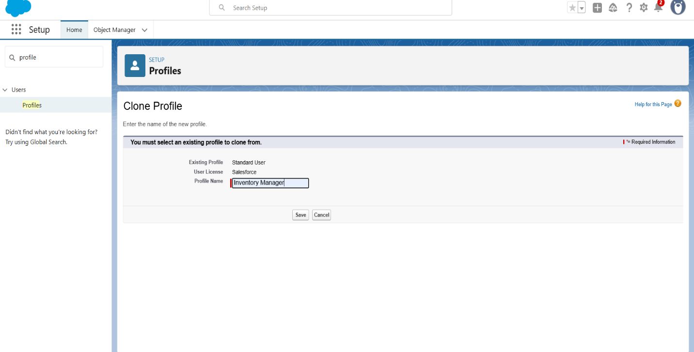

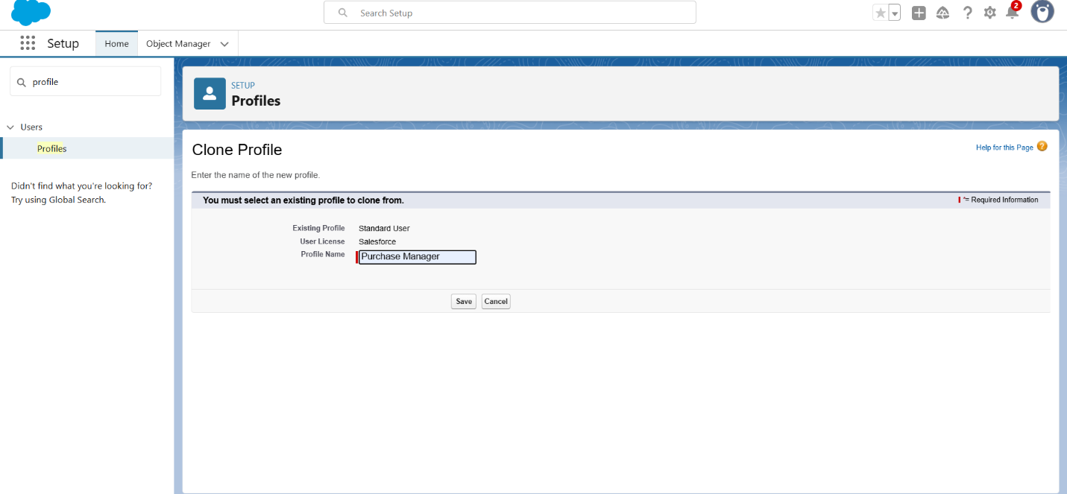

Role

* To create a purchasing manager role.

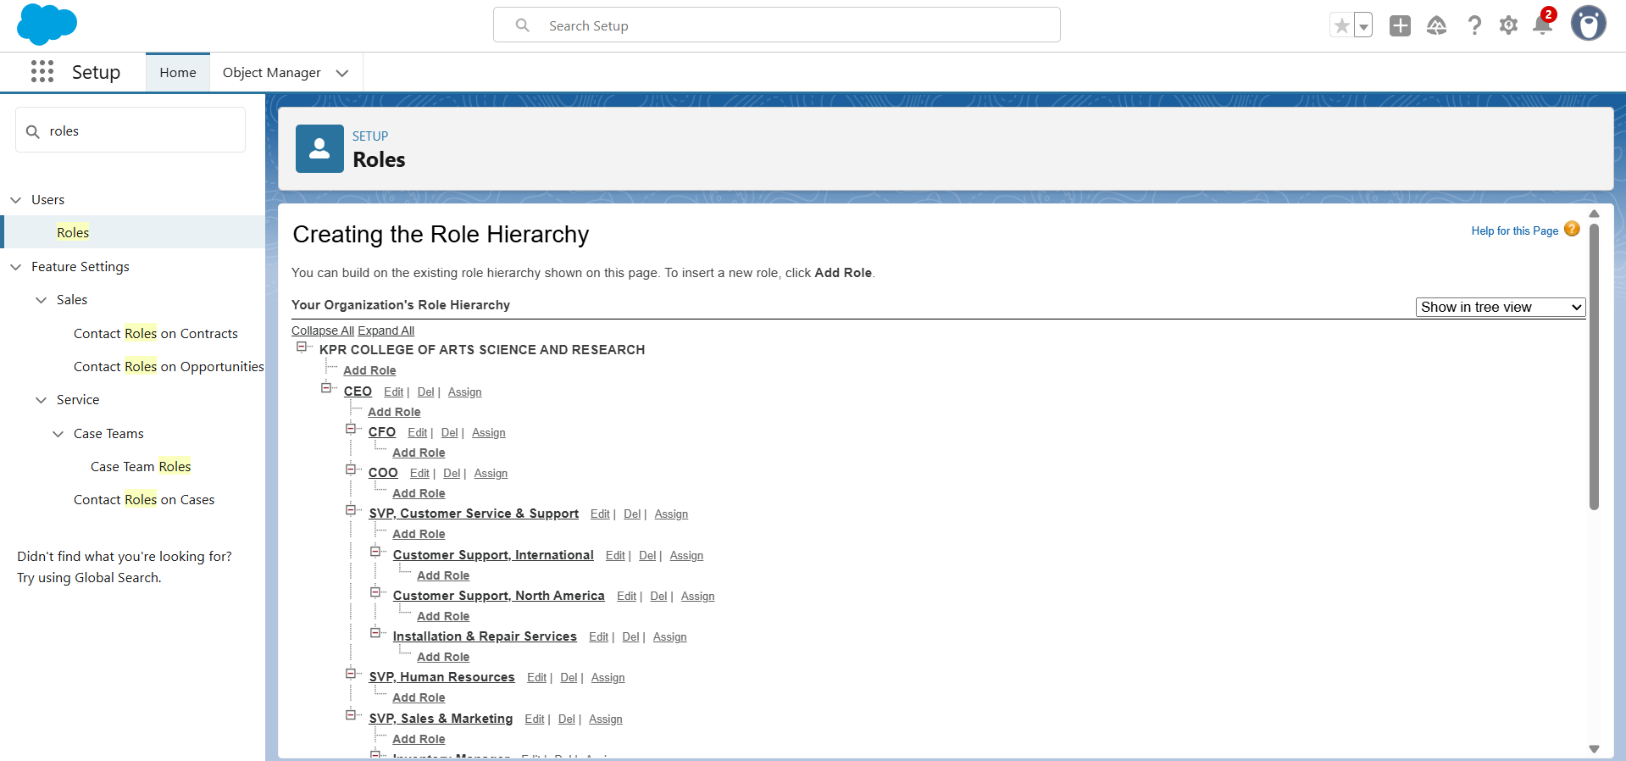

* Created a permission set.

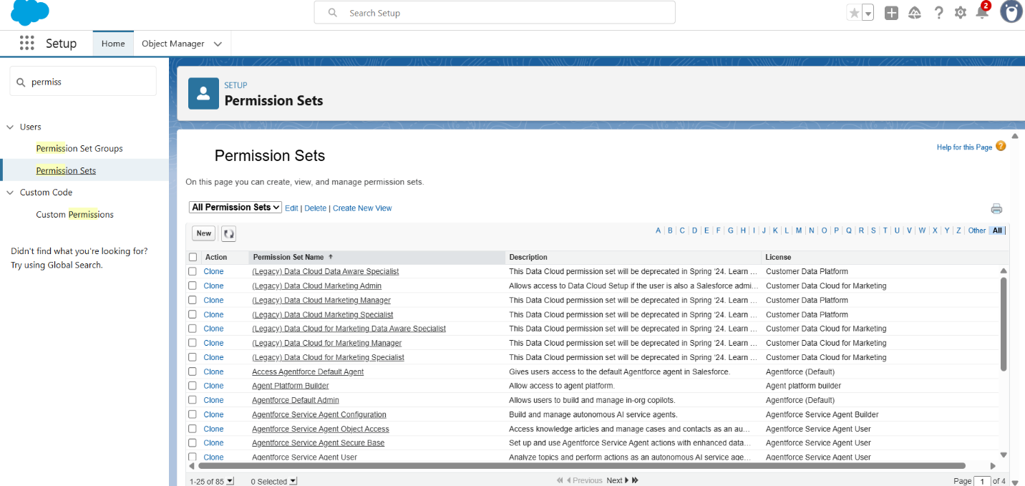

Flows

* Created Flow to update the Actual Delivery Date.

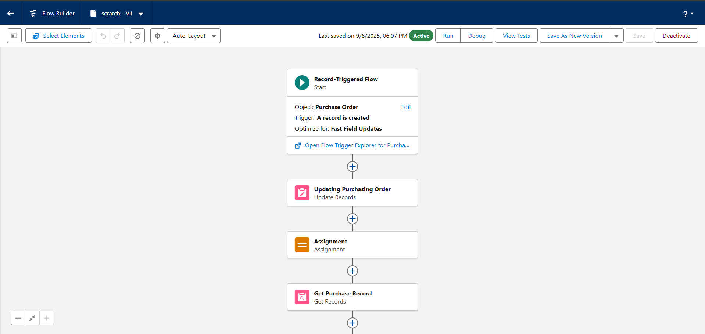

Apex Triggers

* Created a Trigger to Calculate total amount on Order Item.

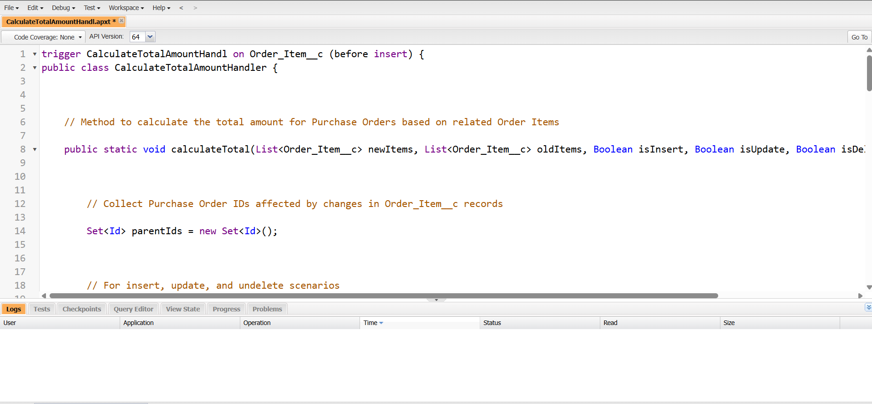

Report

* Create a Purchase Orders based on Suppliers(Summary) Report

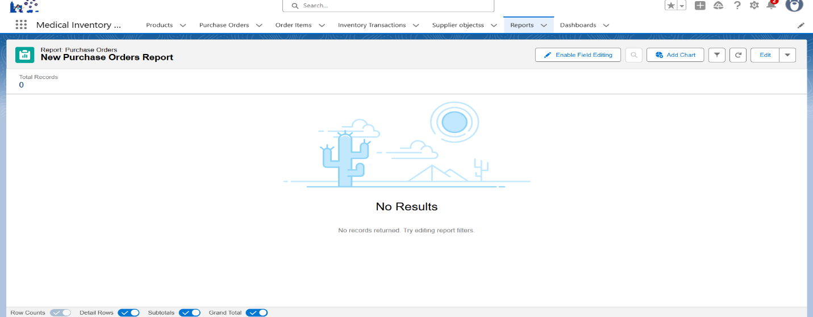

* Create a Complete Purchase Details Report

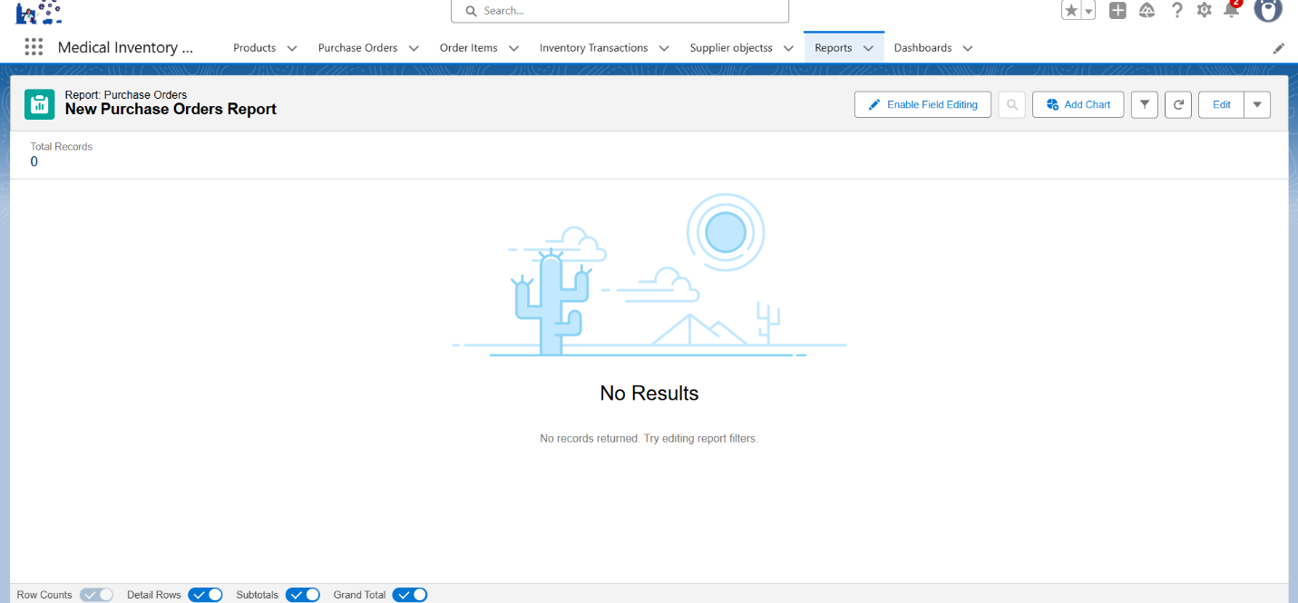

Dashboard

* Created Dashboard

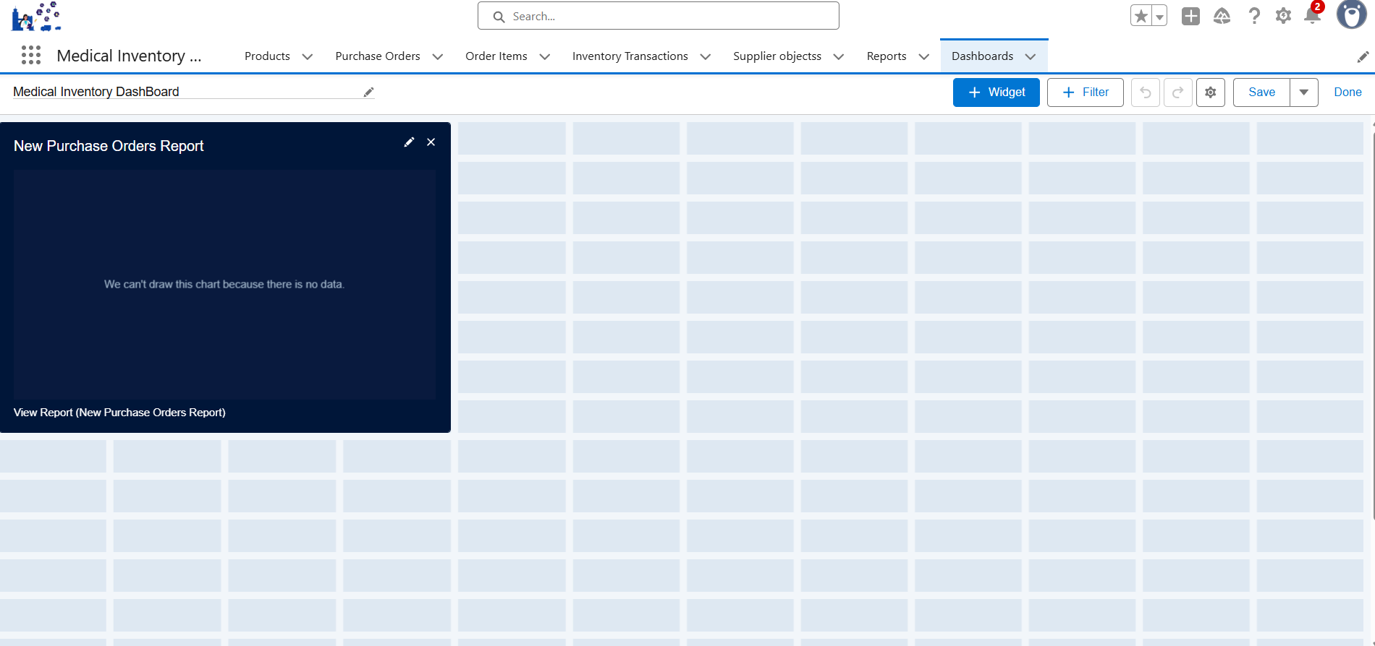

* To view the dashboard

